What’s my function?
N5a
8 → 12 | 21 → 7 | 16 → 10
10 → 25 | 6 → 9 | 10 → 7.5
8 → 32 | 7 → 2⅓ | 14 → 35
¼ → 1 | 4 → 3 | 2 → 3
150 → 50 | 20 → 15 | 4 → 10
80 → 50 | 0.5 → 2 | 4 → 2.5

Mystery functions
N5b
Name
School
What are the mystery functions below? Try to find each function from the three inputs and their corresponding outputs.
Write down as many different ways as you can to describe each function.
Mystery function 1  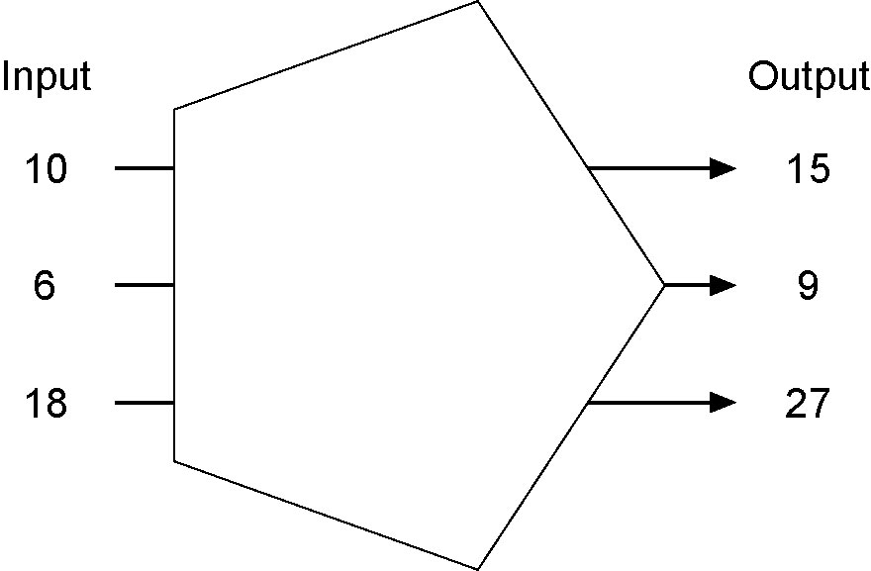 | Mystery function 2  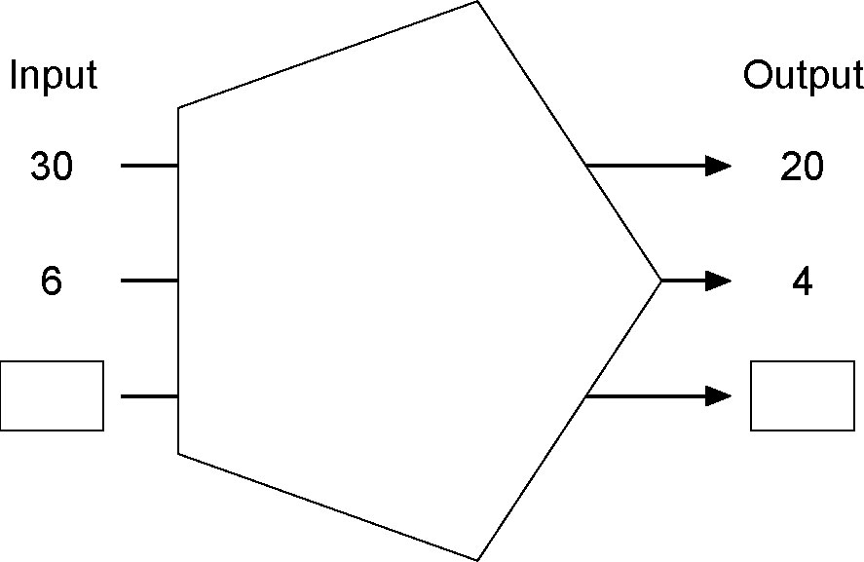  Try to find two numbers to go in the boxes.
Jane says the two mystery functions are the same. Do you agree?
Explain why you think she is right or wrong.

Extension task
Complete this diagram for one of the mystery functions.
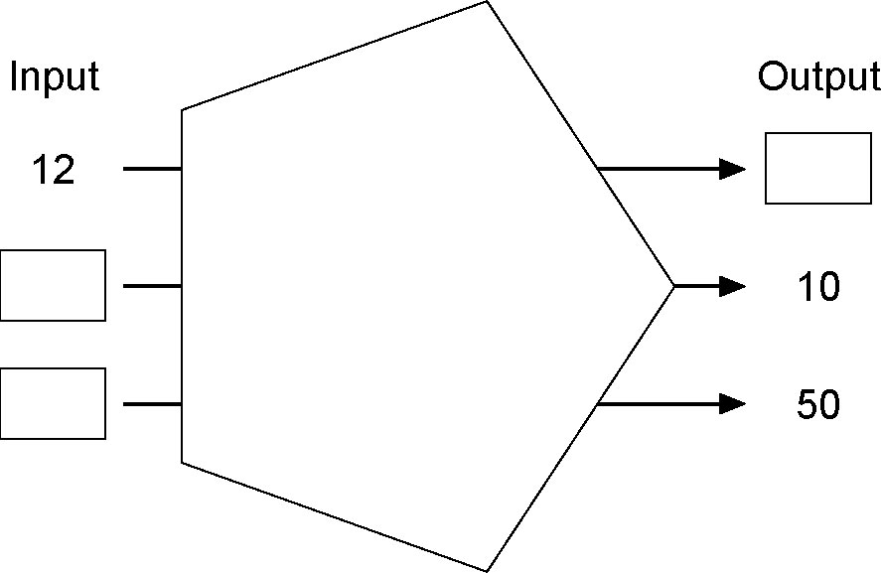

Back to the start
N5c

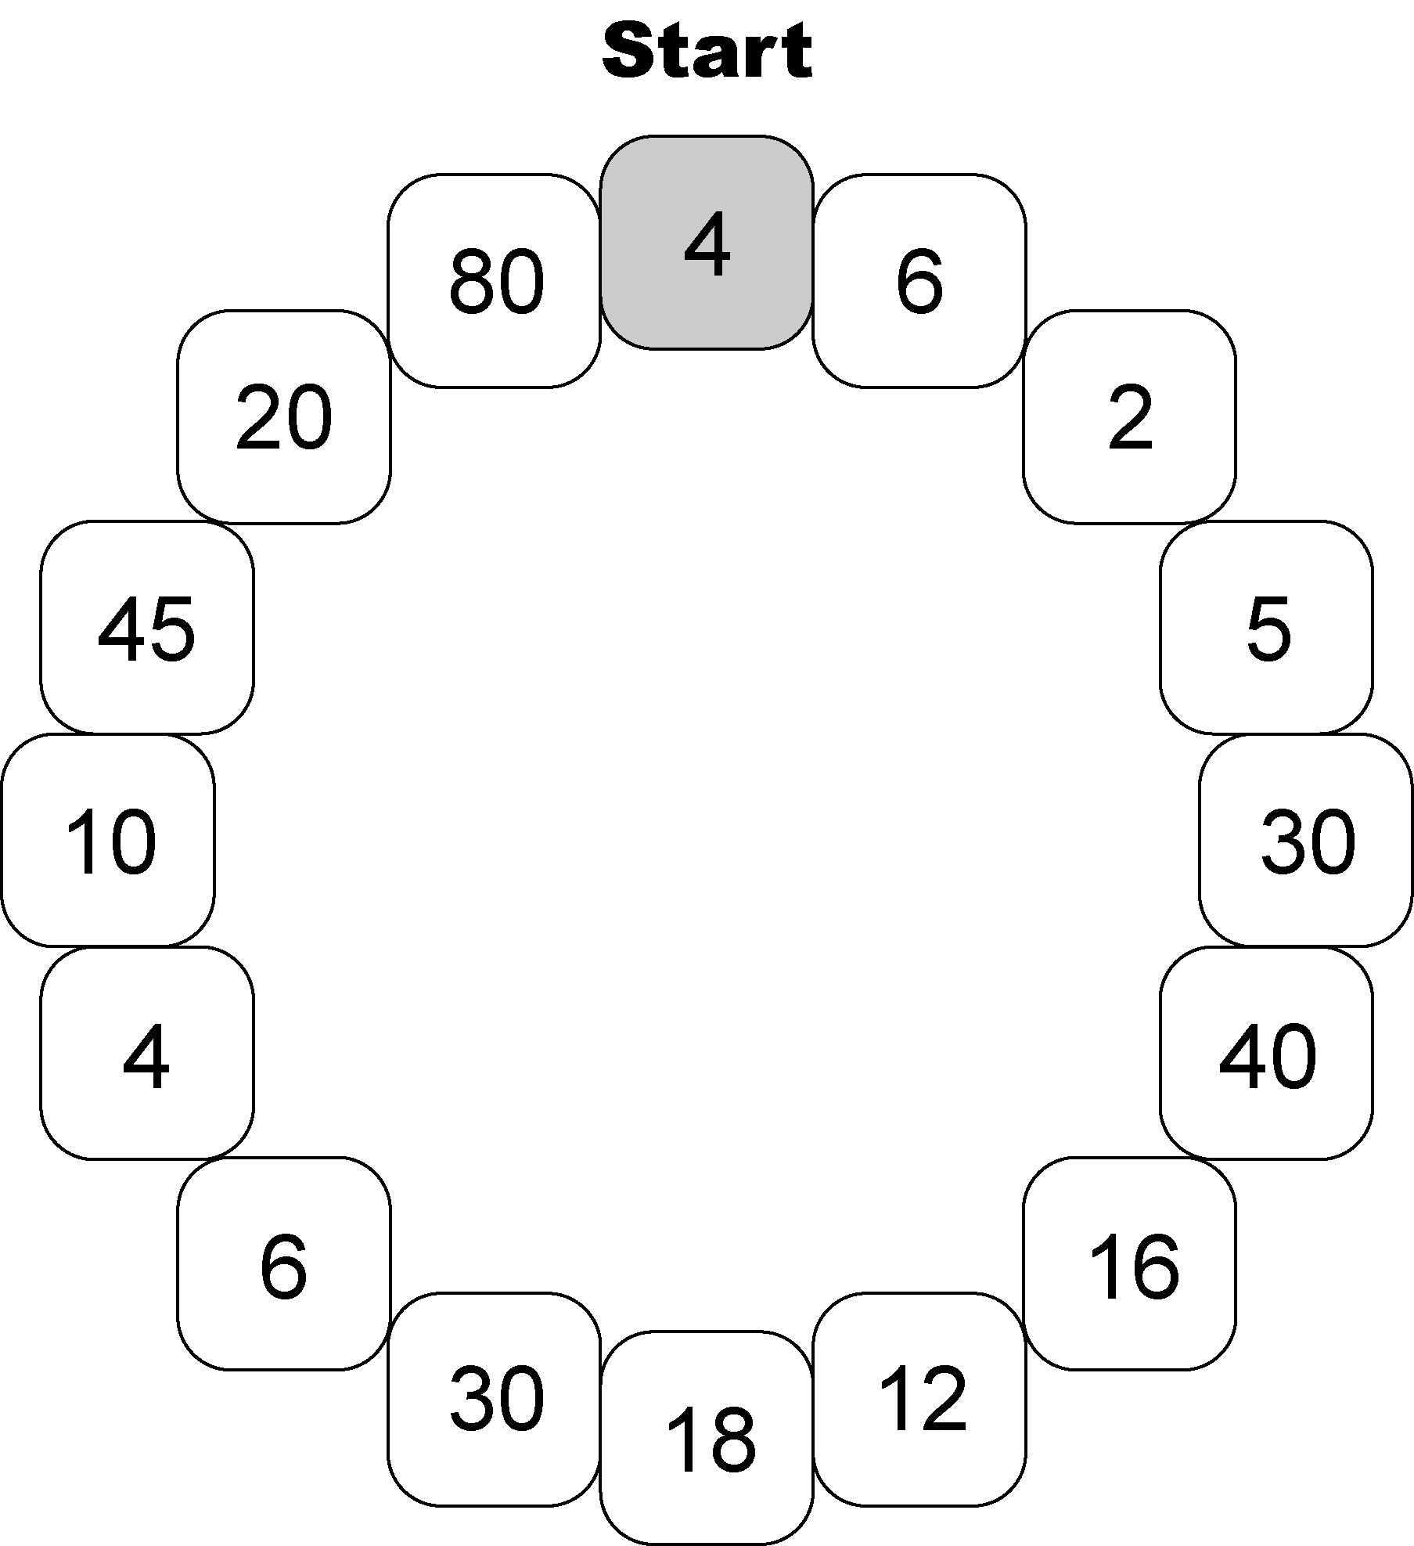

Word problems
N5d
A map is drawn so that 1 cm represents 2.5 km in real life.  On the map the length of a road is 14 cm. How long is the road in real life?  My question | When you change £1, you get about one and a half euros.  How much British money do you need to change to get 12 euros?  My question
For every three tokens you collect, you can send off for a free T-shirt.  How many tokens do you need for seven T-shirts?  My question | Three quarters of a box of chocolates are milk chocolate.  There are 15 milk chocolates. How many chocolates are in the box altogether?  My question
Orange squash is mixed with water in the ratio 1 to 4.  The bottle of squash contains 0.5 litres. How much water do I need to mix with this?  My question | 8 km is about the same distance as 5 miles.  My journey to the cinema is 16 km. About how many miles is this?  My question

Peanut problems
N5e
Name
School
Peanuts cost 60p for 100 g.
• Make up two questions using this fact. Question 1 should be easy to answer but question 2 should be harder.
• For each question, show one way of calculating the answer.

Question 1

How to calculate the answer

Question 2

How to calculate the answer

How well am I doing?
N5f
Name
School

I can recognise the equivalence of percentages, fractions and decimals
(tick a box):
□ on my own
□ with some help

I can solve simple word problems (tick a box):
□ on my own
□ with some help

My next target
I want to get better at:

